Sierra Leone

## Political Stability Estimate Data

The data set shows the political stability estimate of the country each year.

## # A tibble: 19 x 5  
## country iso3c date stability stabilityCategory4   
## <chr> <chr> <dbl> <dbl> <chr>   
## 1 Sierra Leone SLE 1996 -1.69 highly unstable   
## 2 Sierra Leone SLE 1998 -2.17 highly unstable   
## 3 Sierra Leone SLE 2000 -1.87 highly unstable   
## 4 Sierra Leone SLE 2002 -0.689 moderately unstable  
## 5 Sierra Leone SLE 2003 -1.08 highly unstable   
## 6 Sierra Leone SLE 2004 -0.513 moderately unstable  
## 7 Sierra Leone SLE 2005 -0.479 moderately unstable  
## 8 Sierra Leone SLE 2006 -0.302 moderately unstable  
## 9 Sierra Leone SLE 2007 -0.0608 moderately unstable  
## 10 Sierra Leone SLE 2008 -0.238 moderately unstable  
## 11 Sierra Leone SLE 2009 -0.289 moderately unstable  
## 12 Sierra Leone SLE 2010 -0.237 moderately unstable  
## 13 Sierra Leone SLE 2011 -0.168 moderately unstable  
## 14 Sierra Leone SLE 2012 -0.280 moderately unstable  
## 15 Sierra Leone SLE 2013 -0.175 moderately unstable  
## 16 Sierra Leone SLE 2014 -0.104 moderately unstable  
## 17 Sierra Leone SLE 2015 -0.103 moderately unstable  
## 18 Sierra Leone SLE 2016 -0.160 moderately unstable  
## 19 Sierra Leone SLE 2017 0.0298 moderately stable

## Political Stability Estimate Plot

The plot shows the trends of stabilization and destabilization for the each country.

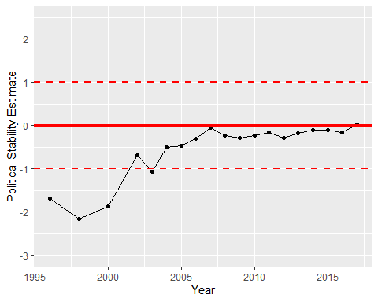

Political Stability Trend